Reflection of Lab Exercise week 3

**Web and Mobile Development**

* This week we learnt about JS functions, how to write functions in Java script, Arrow function, and how to export a function with argument.
* To created local module in nodejs.
* To export functions and variables to other modules.
* To use a module declared in a separate file.
* How to access nodejs core module.

we need to install visual studio code and nodejs on the computer to perform the programm.

Open a new file and select java script language

New file called index.js is saved in a folder. Now star to write the code.

Exercise 1

First line of code starts with function named Employee that passes two parameters (name and salary). Next code Console.log is used to print or display a message or variable value in the terminal window. The message is displayed in the terminal window.

Exercise 2

Create an arrow functions

Arrow functions are a more recent approach to defining JavaScript functions. They are shorter and do not need a name, in contrast to traditional JavaScript functions.

This is the arrow function with one parameter (java). You can see the message in window.

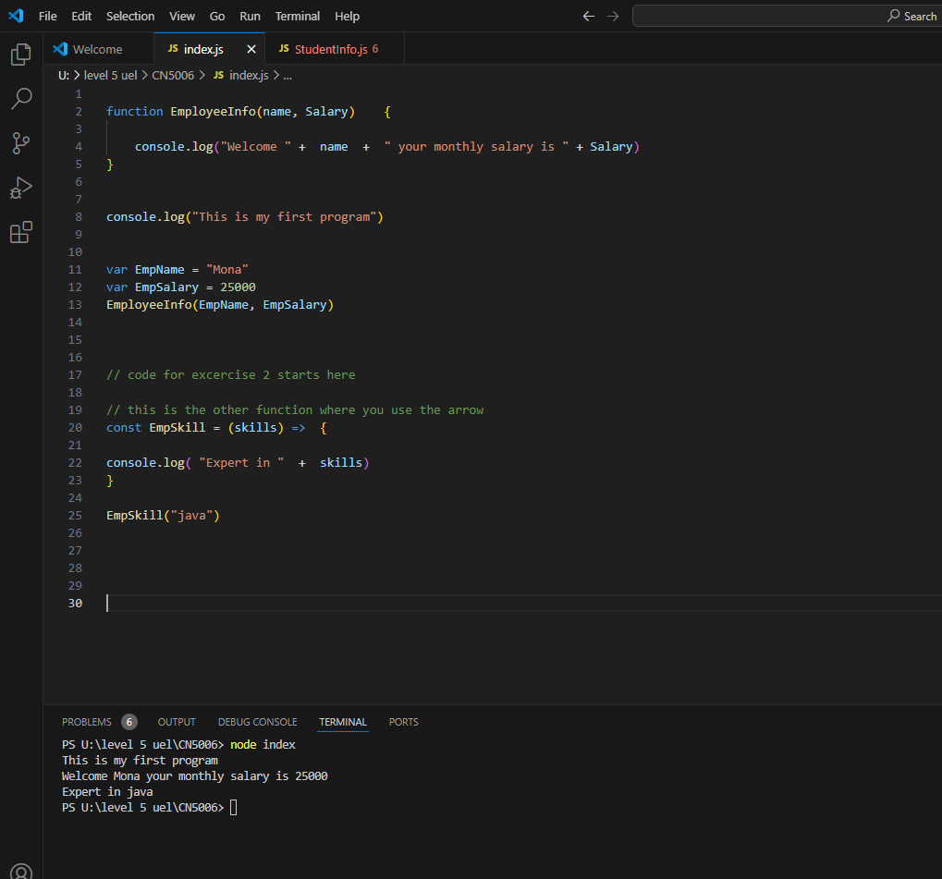

Exercise 3

Other modules named studentinfo.js and person.js is created in the same folder as index.js.

There are three Arrow functions used in the studentinfo.js file.

Studentinfo.js file

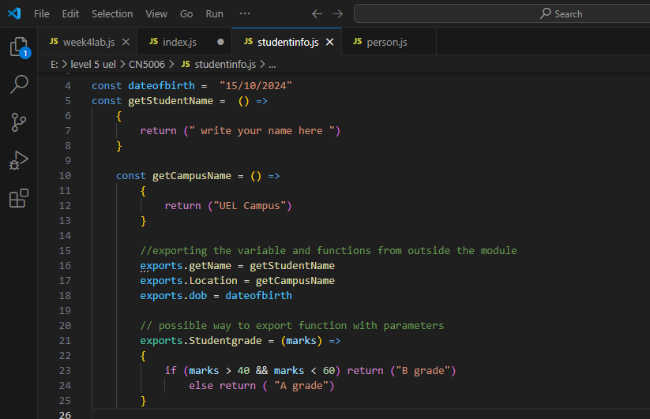

Person.js file

Use the functions and objects defined in studentinfo.js and person.js files in index.js file

We use require word in code to import a module in NodeJS and ./ shows us the path for the file where it is saved.

This is the final output in the terminal window.

Exercise 4

Core module used is os.

Displays the laptop information such as temporary directory, user info, hostname , free memory, network Wi-Fi, operating system etc. on the terminal using os Module.

